PROJECT TITLE : CRM APPLICATION FOR WHOLESALE RICE MILL

# Project Overview :

# The Rice Mill CRM Application is a comprehensive solution for managing and simplifying rice production and sales tracking. It enables daily reporting on rice quantity, type, and sales, which is then communicated to the owners. This CRM leverages customer relationship management to enhance customer engagement, streamline operations, and improve efficiency in the rice mill factory. The project aims to deliver a user-friendly application that meets the specific operational needs of a rice mill.

# Objectives :

**Business Goals**: The Rice Mill CRM Application will automate daily production and

revenue reporting, providing owners with clear insights into operational

performance. It will also implement customer analytics to identify buying trends and

popular rice varieties, enabling targeted marketing and better customer understanding.

Additionally, the application will streamline resource allocation by forecasting demand

and analyzing sales patterns, helping the business optimize inventory and manage

resources efficiently.

**Specific Outcomes**: The Rice Mill CRM Application will automate daily production and

revenue reporting, track customer buying trends, and optimize resource allocation based on

demand forecasts and sales patterns, providing clear insights for operational efficiency.

# Salesforce Key Features and Concepts Utilized :

# Reporting and Dashboards:

# 

* **Daily Sales and Production Reports**: Generates detailed reports on how much rice Iis produced & sold each day.
* **Revenue Reports**: Provides insights into daily revenue generated.
* **Customer Analytics**: Tracks popular rice types and most frequent buyers.
* **Resource Allocation**: Helps owners understand data for better resource allocation and future planning.

# Rollup Summary Field:

* **Purpose**: Summarizes data from a child object to a parent object that shares a master-detail relationship.
* **Functions**:Can use COUNT, SUM, MIN, and MAX functions.

# 

# Cross-Object Formula Field:

* **Purpose**: References fields from another object in Salesforce.

# Function: Calculates the total amount payable by multiplying the number of rice units taken by the price per kg.

# Validation Rules:

* **Purpose**: Ensures data integrity by validating user inputs.
* **Is Blank Formula**: Verifies if a field is blank and displays an error message if the rule returns a value of "True."

# Permission Sets:

* **Wide Defaults (OWD)**: Defines the baseline level of access for the most restricted user.
* **Roles and Access**:
* **Organization Owner**: Can view records of employers and workers.
* **Employer**: Can view records of workers.

# Detailed Steps to Solution Design :

# Activity 1: Creating Developer Account and Account activation.

# Steps:

# 

* On the sign up form, enter the following details
* Click on sign me up after filling these.
* First name & Last name
* Email
* Role : Developer
* Company : College Name
* Country : India
* Postal Code : pin code
* Username : should be a combination of your name and company
* This need not be an actual email id, you can give anything in the format.

username@organization.com

# C:\Users\tharu\OneDrive\Pictures\Screenshots\Screenshot 2024-10-28 114005.png

**ACTIVATION :**

# 

# Go to the inbox of the email that you used while signing up. Click on the verify account to activate your account. The email may take 5-10mins

# 

**Activity 2: Objects**

Salesforce objects are of two types:

1. **Standard Objects**: Standard objects are the kind of objects that are provided by

salesforce.com such as users, contracts, reports, dashboards, etc.

1. **Custom Objects**: Custom objects are those objects that are created by users. They

supply information that is unique and essential to their organization.

are the heart of any application and provide a structure for sharing

data.

**Steps:**

### Create Supplier Object

* From the setup page >> Click on Object Manager>> Click on Create>>Click on Custom Object.
* Enter the label name>>supplier
* Plural label name>>supplier
* Enter Record Name Label and Format
* Record Name >> supplier Name
* Data Type>>Text
* Click on Allow reports and Track Field History and allow search
* Allow search >> Save.

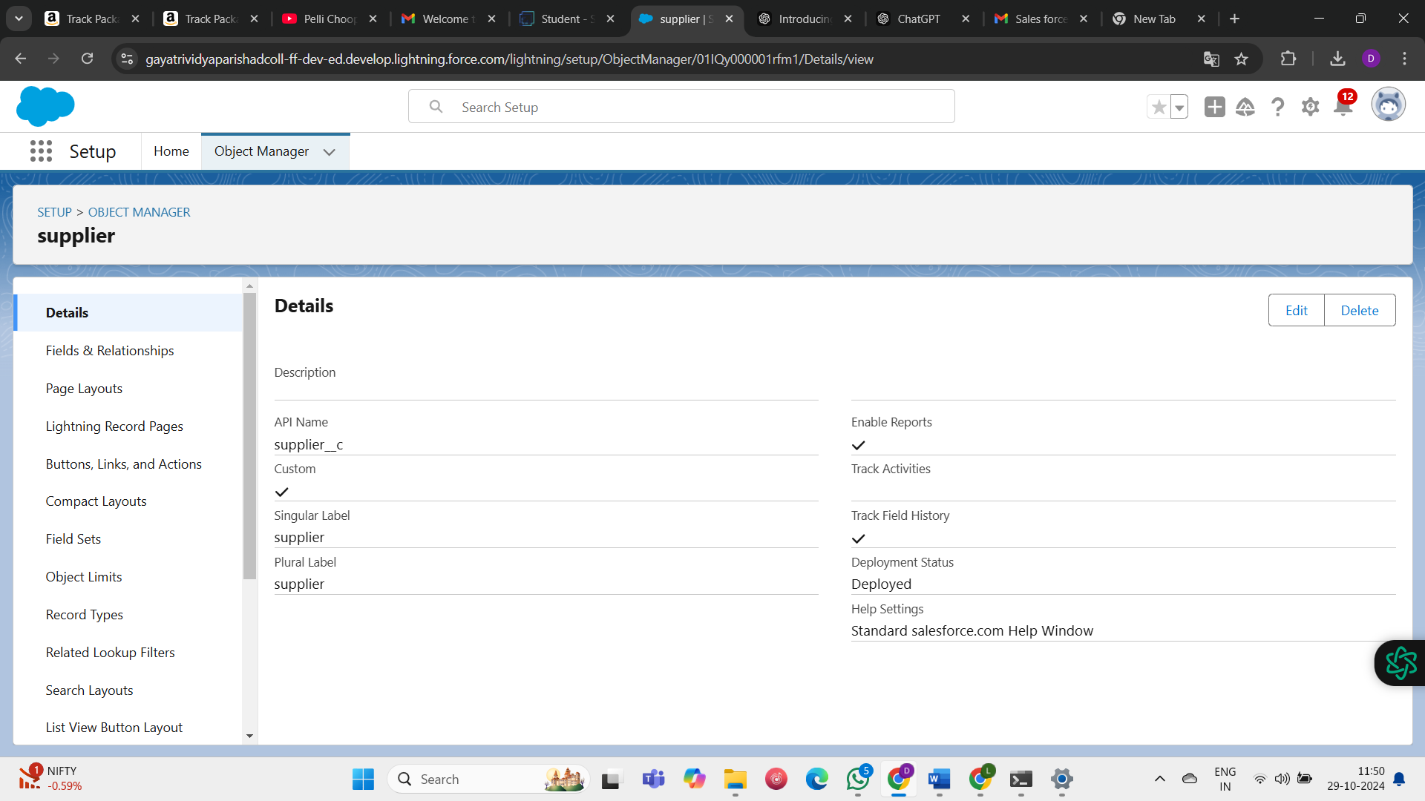

### Create Rice mill Object

* From the setup page >> Click on Object Manager>>Click on Create >> Click on Custom Object.
* Enter the label name>>rice mill
* Plural label name>> rice mills
* Enter Record Name Label and Format
* Record Name >>
* Data Type >> Auto Number
* Display Format >> rice-{000}
* Starting number >> 1
* Click on Allow reports and Track Field History, Allow Search and Save.

### 

# Create consumer Objects

# Use these display format for the consumer

# label name >> consumer

# Plural label name >> consumers

# Display Format >> consumers-{000}

# Starting number >> 1

# 

# Create rice details Objects

# Use these display format for the rice details

# label name >> rice details

# Plural label name >> rice details

# Display Format >> rice-{000}

# Starting Number >>1

**Activity 3: Tabs**

* Creating a Custom Tab
* To create a Tab:( supplier)
* Go to setup page >> type Tabs in Quick Find bar >> click on tabs >> New (under custom object tab)
* Select Object( supplier) >> Select the tab style >> Next (Add to profiles page) keep it as default >> Next (Add to Custom App) uncheck the include tab .
* Make sure that the Append tab to users' existing personal customizations is checked.
* Click save.

# 

# Activity 4: The Lightning App

# Create a Lightning App

# Go to setup page >> search “app manager” in quick find >> select “app manager” >> click on New lightning App

# Fill the app name in app details as MY RICE >> Next >> (App option page) keep it as default >> Next >> (Utility Items) keep it as default >> Next.

# Upload a photo that is related to your app.

# To add Navigation Item:

# Select the items (supplier, rice mill, consumer , Rice details ) from the search bar and move it using the arrow button >> Next.

# To Add User Profiles:

# Search profiles (System administrator) in the search bar >> click on the arrow button >> save & finish.

# Activity 5: Fields

# Creating the number field in rice details object

# Go to the setup page >> click on object manager >> From drop down click edit for rice details object

# Click on fields & relationship >> click on New.

# Select Data type as “Number” and click Next.

# Given the Field Label as “ rice distributed ” and length as “ 5 ”.

# Field Name will be auto populated, and click on Next- Next >> Save.

# 

# Creating Junction Object

# Creating junction object as rice details with supplier & rice mill

# Go to the setup page >> click on object manager >> From drop down click edit for rice details object

# Click on fields & relationship - click on New.

# Select “Master-Detail relationship” as data type and click Next.

# Select the related object “ supplier ” and click next.

# Give Field Label as “supplier Name” and click Next

# Next >> Next >> Save & New.

# Follow the same steps from 1 to 3.

# Select the related object “ rice mill ” and click Next.

# Give Field Label as “rice mill 1(one)” and click Next.

# Next >> Next >> Save.

# Creating a Master-Detail Relationship

# Go to the setup page >> click on object manager >> From drop down click edit for consumer object.

# Click on fields & relationship >> click on New.

# Select “Master-Detail relationship” as data type and click Next.

# Select the related object “ rice mill”.

# Give Field Label as “rice mill name” and click Next.

# Next >> Next >> Save.

# 

# 

# Creating the Roll-up Summary

# Go to setup >> click on Object Manager >> type object name(supplier) in search bar >> click on the object.

# Now click on “Fields & Relationships” >> New

# Select the data type as “Rollup summary ”,and click Next.

# Give the Field label as “ sum of rice distributed ”,Field Name will be Auto generated, and click Next.

# Select the summarized object as “ rice details ”.

# Select the Rollup type as “sum”.

# Select the field to aggregate as “ rice distributed ”, and click Next >>Next >>Save

# Follow the same steps for the rice mill Object from 1 to 3

# Give the Field label as “ rice distributed to shops ”,Field Name will be Auto generated, and click Next.

# Select the summarized object as “ rice details ”.

# Select the Rollup type as “sum”.

# Select the field to aggregate as “ rice distributed ”, and click Next >> Next >> Save.

# Note : create the field as “ rice taken by shops in kgs” using number datatype in consumer object

# Follow the same steps for the rice mill Object from 1 to 3

# Give the Field label as “ rice taken ”,Field Name will be Auto generated, and click Next.

# Select the summarized object as “ consumer”.

# Select the Rollup type as “sum”.

# Select the field to aggregate as “ rice taken in shops ”, and click Next >> Next >> Save.

# C:\Users\tharu\OneDrive\Pictures\Screenshots\Screenshot 2024-10-28 124013.png

# C:\Users\tharu\OneDrive\Pictures\Screenshots\Screenshot 2024-10-28 124021.png

# Creating the validation rule

# Go to the setup page >>click on object manager >> From drop down click edit for consumer object.

# Click on the validation rule >> click New.

# Enter the Rule name as “Phonenumberoremailblankrule ”.

# Enter the description as “phone number and email number should not be blank”.

# Enter the formula as “OR( ISBLANK( phone_number__c ) , ISBLANK( email__c ) )” and check the syntax.

# Under the error message write as”please fill in your phone number.”

# Select error location “top of page”.

# Save the validation rule.

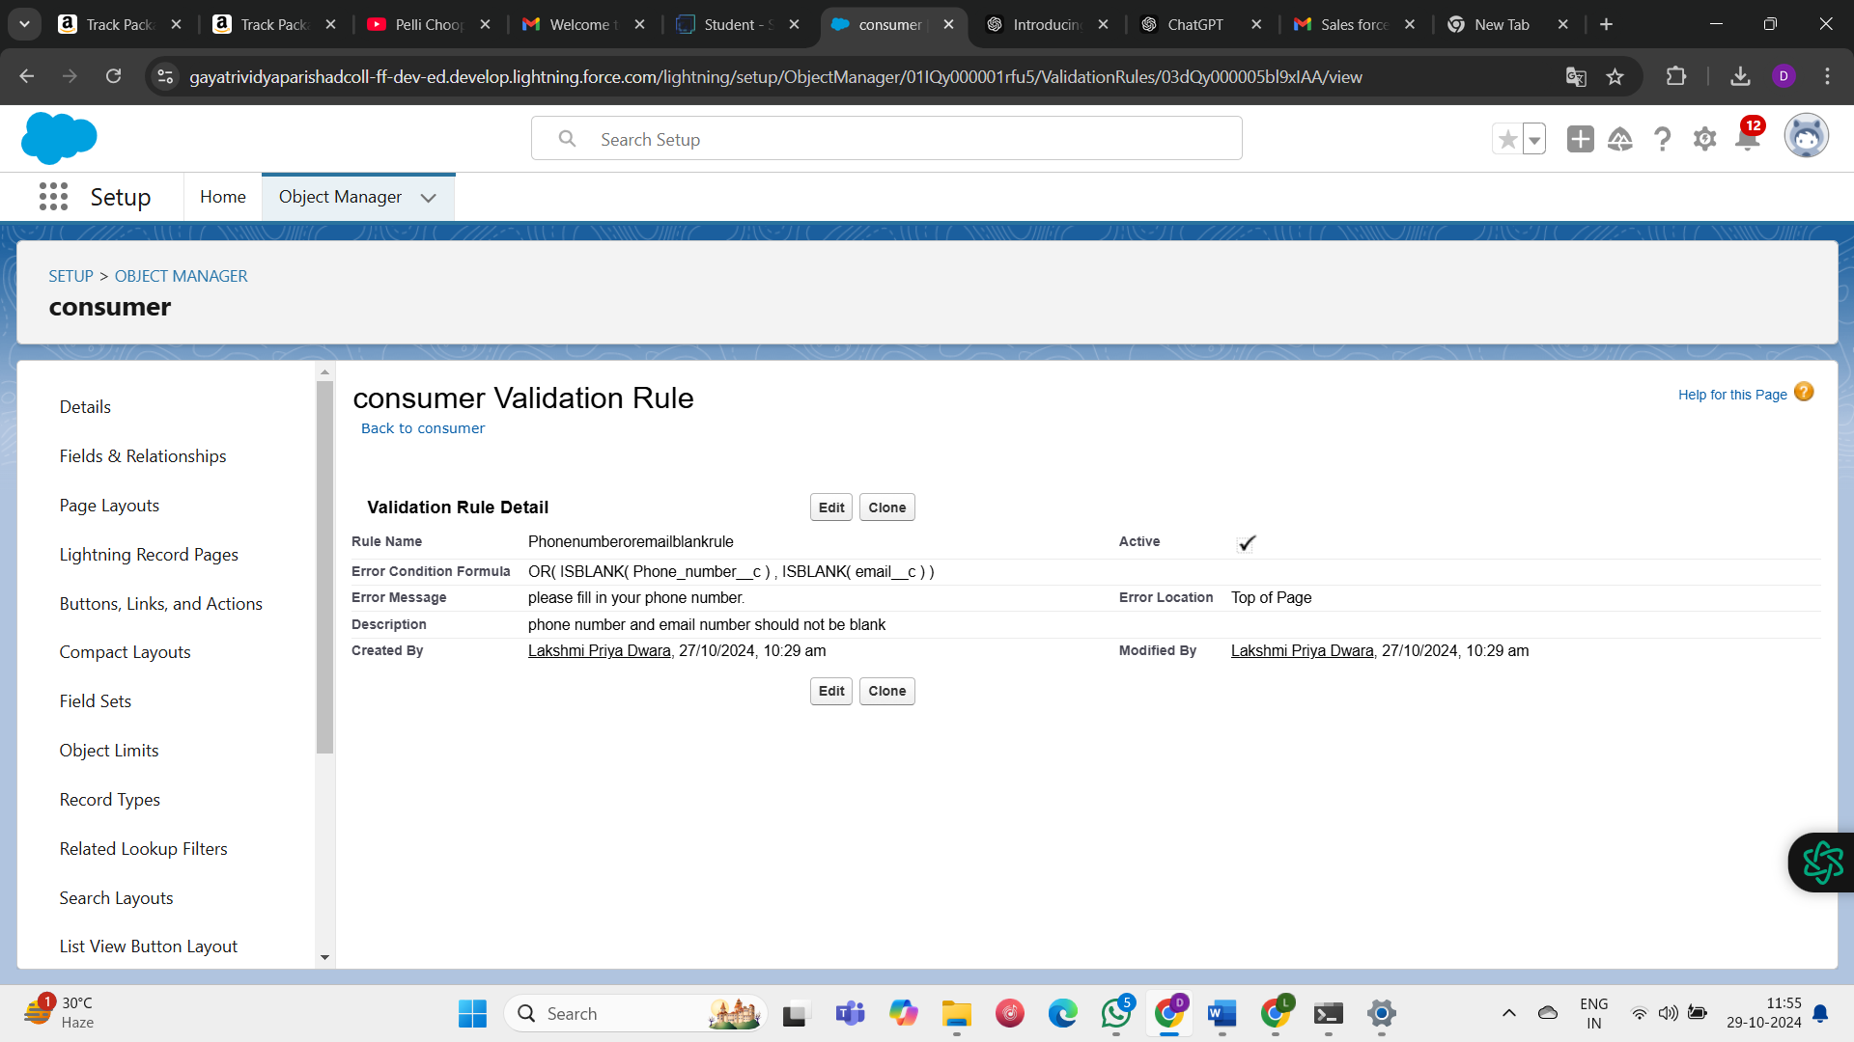

**PAGE LAYOUTS**

* Go to Setup >> Click on Object Manager >>Search for the object (consumer) >> From drop down select the object and click on it.
* Click on Page layout >> Click on New.
* Select the existing page layout, and give the page layout name as “consumer layout”, and click save.
* Drag and drop the section field to consumer details and create the section.
* Enter the section name as “Personal details”, - click Ok.
* Now drag the fields to this section that mentioned , they are
* First name , last name , consumer name , phone number, email, rice mill name.
* Follow the same process for another two sections as shown above , they are
* One section is “ rice details ” , drag the fields that are
* Rice taken by shop, rice type.
* Another section is “Receipt details ”, and drag the fields that are
* Mode of payment , Amount paid.
* Then , Click save.

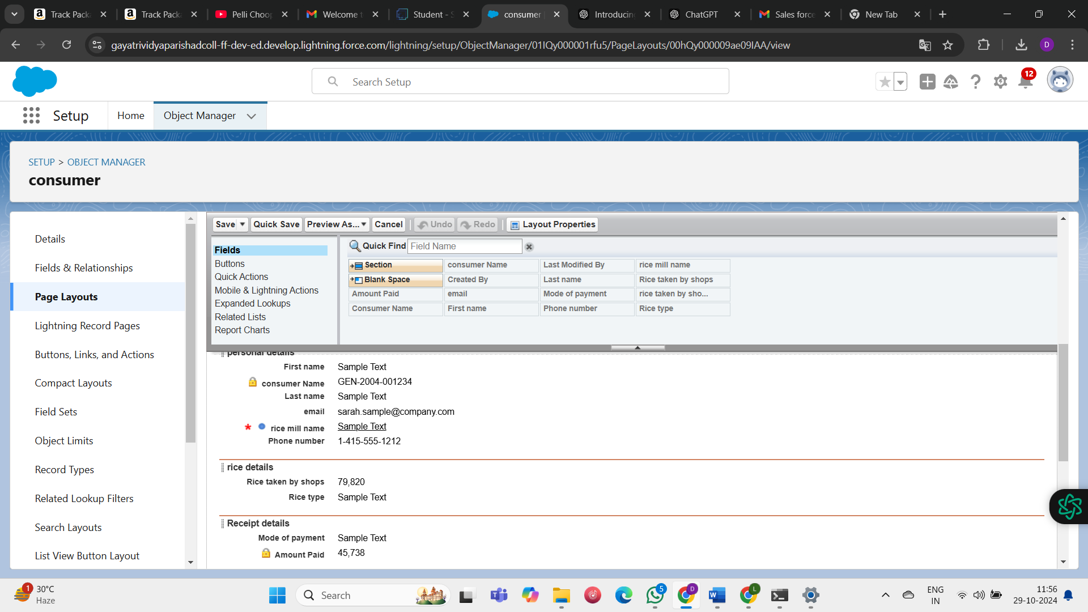

**PROFILES**

A profile is a group/collection of settings and permissions that define what a user can do in salesforce. Profile controls “Object permissions, Field permissions, User permissions, Tab settings, App settings, Apex class access, Visualforce page access, Page layouts, Record Types, Login hours & Login IP ranges. You can define profiles by the user's job function. For example System Administrator, Developer, Sales Representative.

**Owner Profile:**

* Go to setup >> type profiles in quick find box >> click on profiles >> clone the desired profile (Standard User) >>enter profile name (owner) >> Save.
* Scroll down to Custom Object Permissions and Give access permissions for consumers, rice details , rice mill and suppliers objects as mentioned in the below diagram.
* Give access and save it**.**

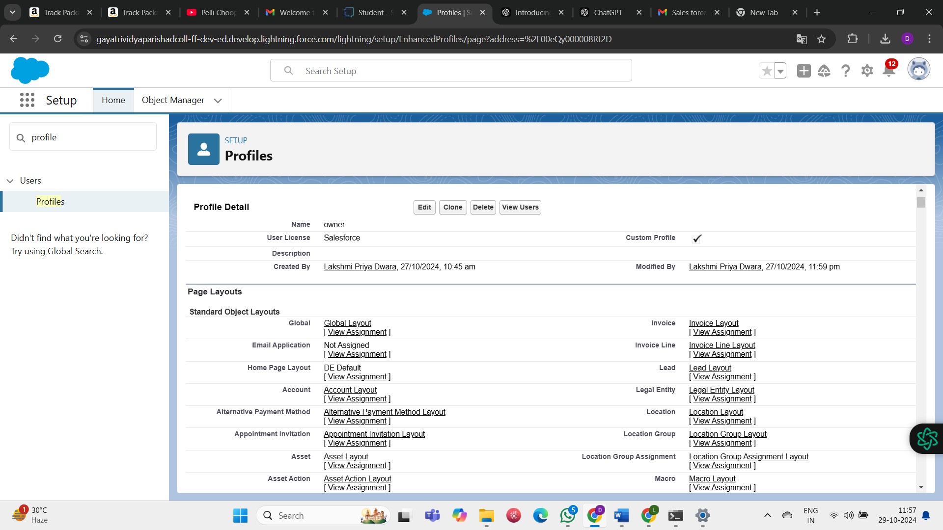

**Employer Profile**

* Go to setup >> type profiles in quick find box >>click on profiles >> clone the desired profile (Standard Platform User) >> enter profile name (employer) >> Save.
* While still on the profile page, then click Edit.
* Select the Custom App settings as default for the rice mill.
* Scroll down to Custom Object Permissions and Give access permissions for consumer, rice details , rice mill and suppliers objects as mentioned in the below diagram.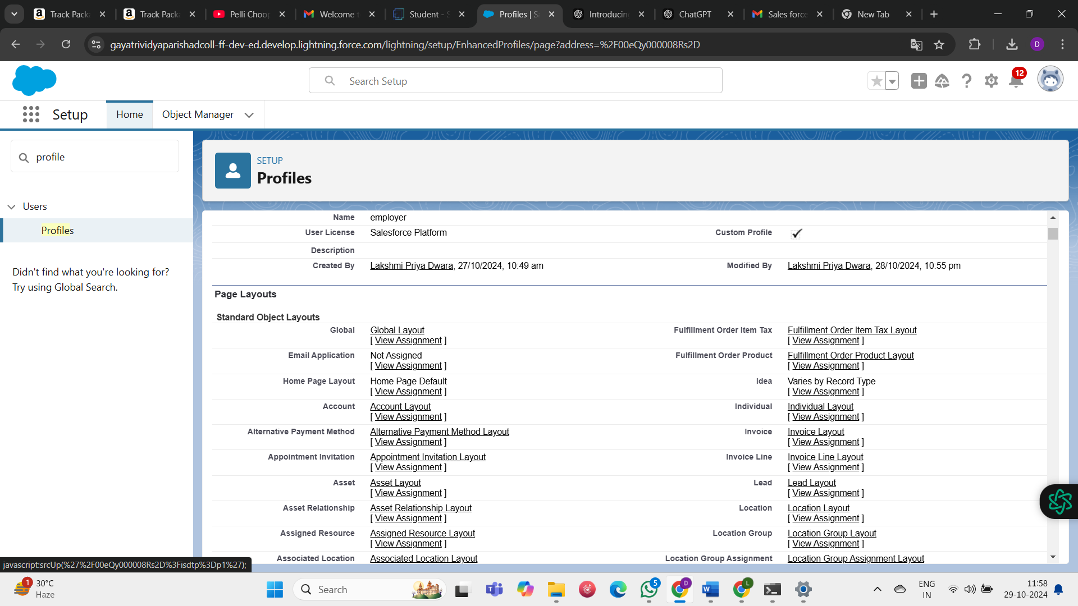

**Worker Profile**

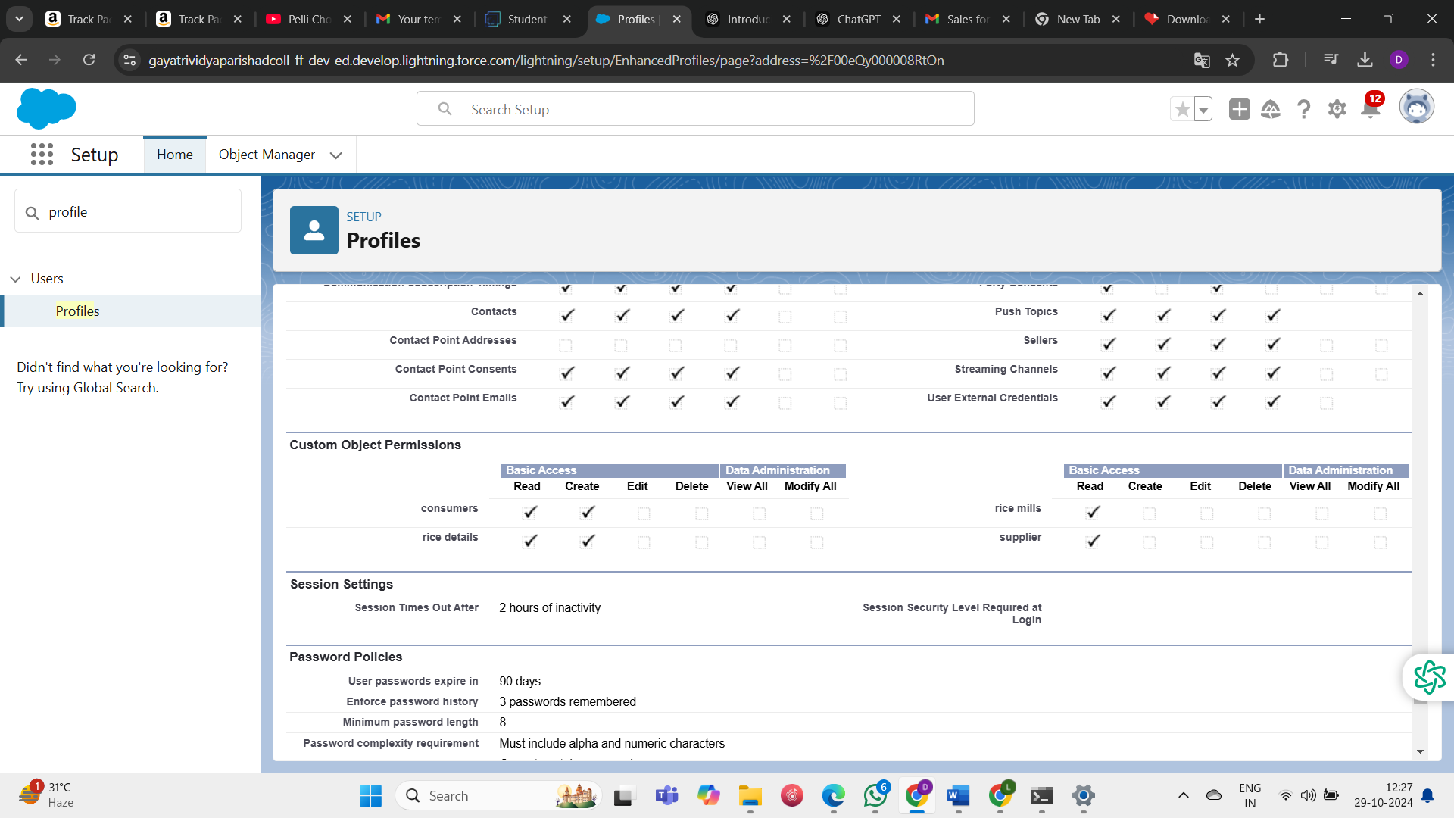



### Go to setup >> type profiles in quick find box >> click on profiles >> clone the desired profile (Standard Platform User) >> enter profile name (worker) >> Save.

### While still on the profile page, then click Edit.

### Select the Custom App settings as default for the rice mill.

### Scroll down to Custom Object Permissions and Give access permissions for consumer, rice details , rice mill and suppliers objects as mentioned in the below d

**Role & Role Hierarchy**

**Creating owner Role:**

* Go to quick find >> Search for Roles >> click on set up roles.
* Go to quick find >> Search for Roles >> click on set up roles.
* Click on Expand All and click on add role under whom this role works.
* Give Label as “owner” and Role name gets auto populated. Then click on Save.

**Creating employer roles**

* Go to quick find >>Search for Roles >>click on set up roles.
* Click plus on CEO role, and click add role under owner.
* Give Label as “employer” and Role name gets auto populated. Then click on Save.
* Repeat the same steps, for another role.
* Click plus on CEO role, and click plus on owner, and click add role under employer.
* give Label as “worker” and Role name gets auto populated. Then click on Save.

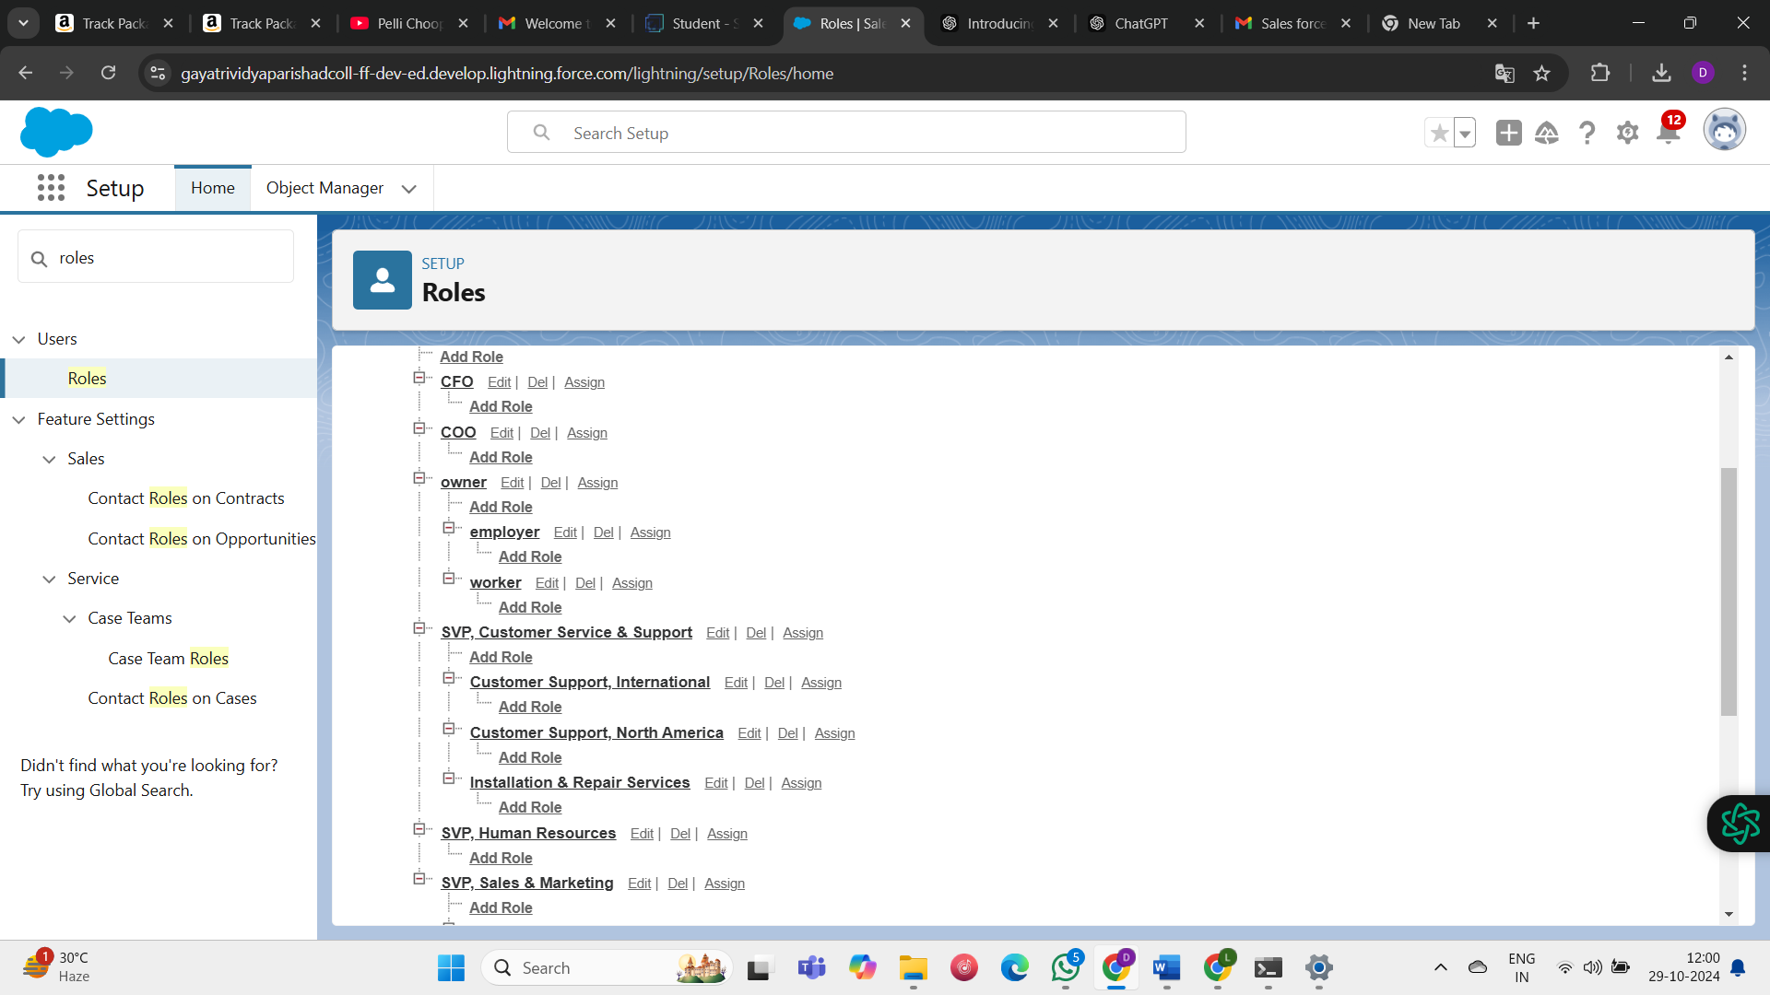

**Report**

**Create Report:**

* Go to the app >>click on the reports tab
* Click New Report.
* select for report type, search for “rice mill with consumers” click on it. And click on start report.
* Their outline pane is opened already, select the fields that are mentioned below in the column section.
* 1.consumer name
* 2.rice type
* 3.rice price/kg
* 4.mode of payments
* 5.amount paid
* Remove the unnecessary fields.
* Select the fields that are mentioned below in the GROUP ROWS section.
* Rice taken by shops
* Click save and run and save the report as “range of amount per day”.and save it.

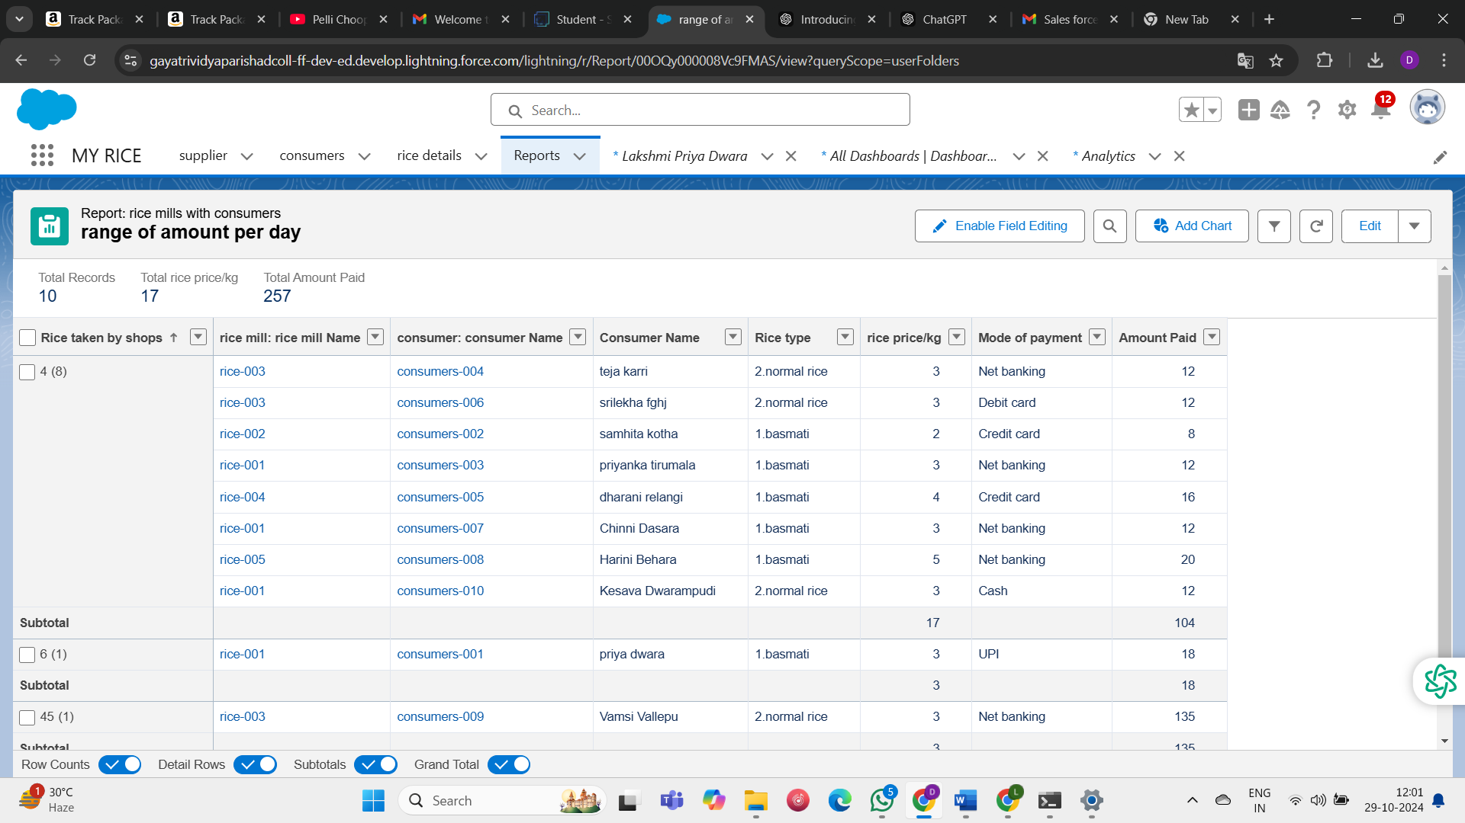

# Testing and Validation:

**Creating an Apex Class(ConsumerRecord):**

1. Login to the Salesforce account and navigate to the gear account in the top right corner.
2. Then we can see the Developer console. Click on the developer console and you will navigate to a new console window.
3. Then you can see many tools in the Toolbar of the new console window. Click on File, New and Apex Class.
4. Enter the name of the class(ConsumerRecord) to create a new class file.

**Code Snippet :**

public class ConsumerRecord {

public static void sendEmailNotification (List<consumer__c> con){

for(consumer__c c:con)

{

Messaging.SingleEmailMessage email = new Messaging.SingleEmailMessage();

email.setToAddresses( new List<String>{c.email__c});

email.setSubject('Welcome to our company');

email.setPlainTextBody('Dear ' + ' '+ ',\n\nWelcome to MY RICE!'+'You have been seen as a valuable customer to us. PLease continue your journey with us, while we try to provide you with good quality resources.'+'\n'+

'We are proud to associate with valuable customers like you and we look forward to collaborating with you by providing more and more exciting discounts or even product offers too.' + '\n'

+'So why taking a step back, take a leap of faith and shop with us more, while we provide with the valuable products and offers'+'\n'+'\n'+'\n'+

'Thankyou for buying '+ '' +'Here are some of the products that are brought by the customers who similarly bought products like this'+'\n\n');

Messaging.sendEmail(new List<Messaging.SingleEmailMessage>{email});

}

}

}

# Creating an Apex Trigger

# While still in the trailhead account, navigate to the gear icon in the top right corner.

# Click on developer console and you will be navigated to a new console window.

# Click on the File menu in the toolbar, and click on new? Trigger.

# Enter the trigger name and the object to be triggered.

# Syntax For creating trigger :

# The syntax for creating trigger is :

# Trigger [trigger name] on [object name]( Before/After event) {

# //Trigger Logic

# }

**Code Snippet :**

# trigger consumerTrigger on consumer__c (After insert) {

# if(trigger.isAfter && trigger.isInsert) {

# ConsumerRecord.sendEmailNotification(trigger.new);

# }

# }

# 

# 6.Key Scenarios Addressed by Salesforce in the Implementation Project.

# 

* **Sales Process Automation**: Salesforce can automate sales workflows, reducing

manual tasks.

* **Customer Support**: Salesforce can provide tools to manage customer service cases

and track resolutions.

* **Data Analytics and Reporting**: Salesforce can generate detailed reports for business

insights.

**DASHBOARDS:**

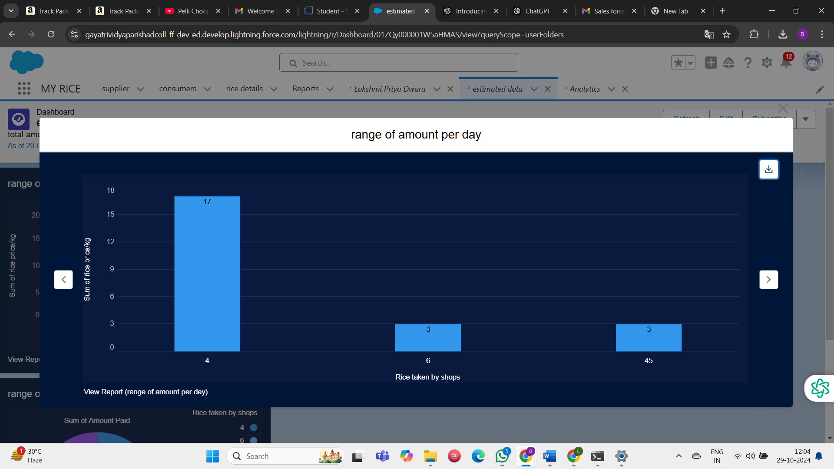

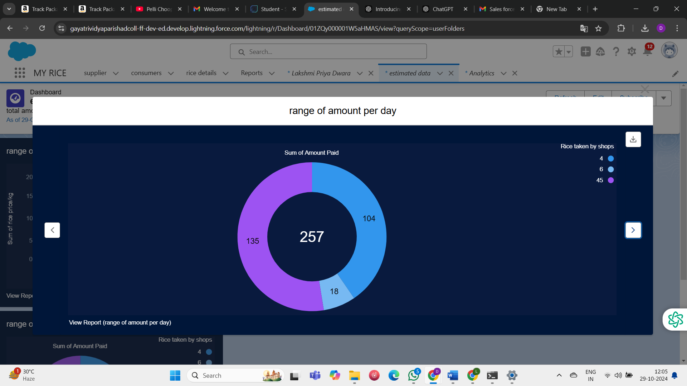

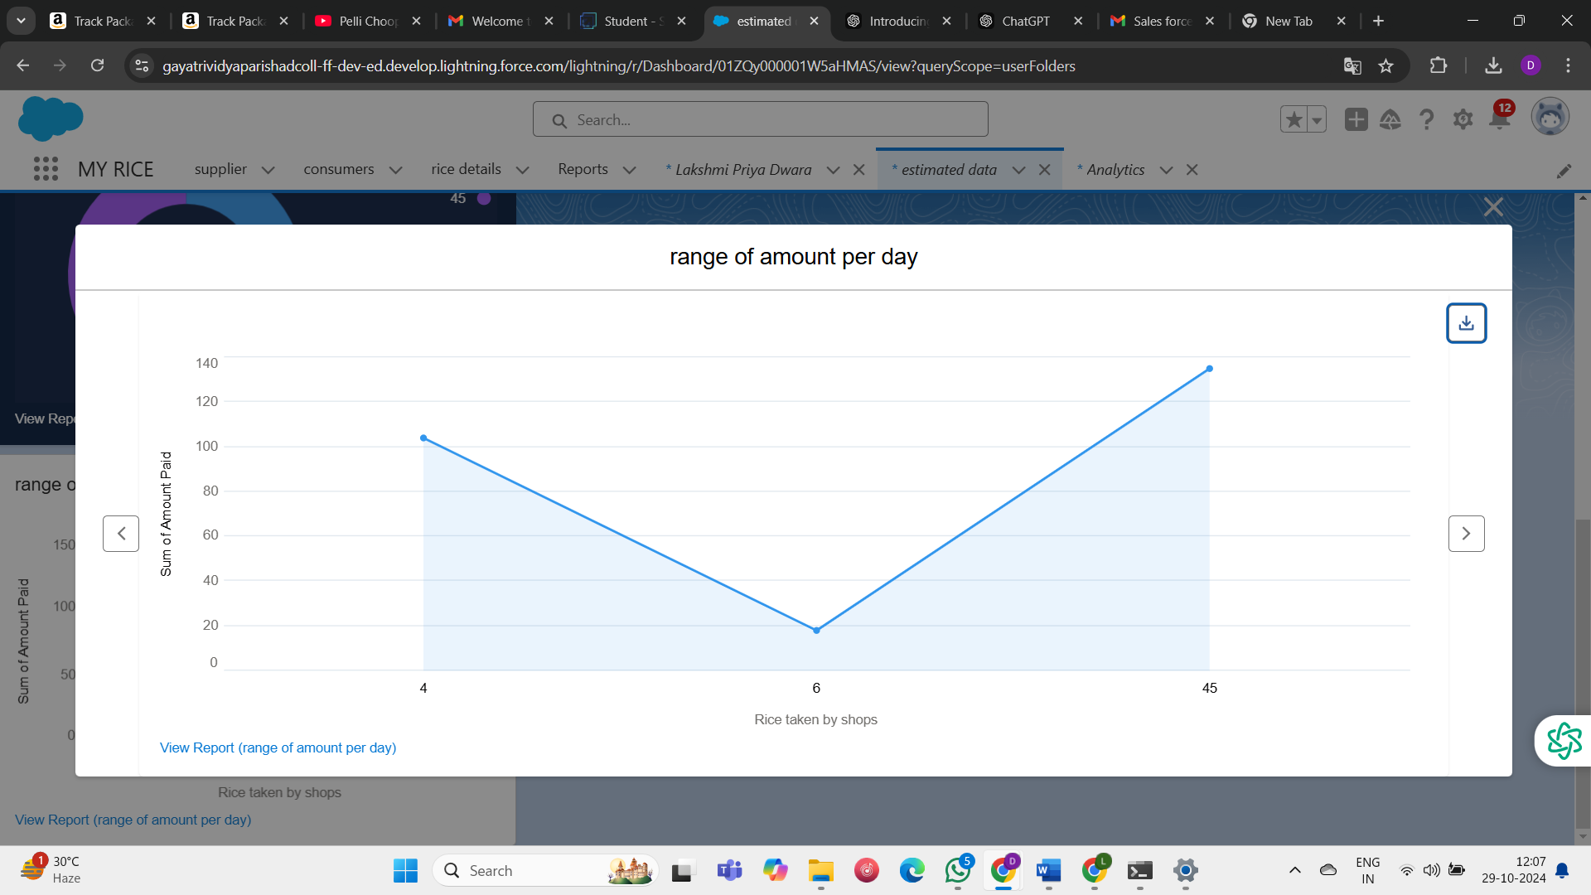

# Resource Management: Salesforce can help allocate resources efficiently based

on business needs.

# 7. Conclusion:

In this project, Salesforce streamlined operational processes by enabling automated data

calculations, real-time reporting, and secure access control. Custom widgets provided

visual insights into rice sales, production, and revenue, enhancing decision-making.

Validation rules ensured data accuracy, while role-based access protected sensitive

information. Rollup summaries and formulas reduced manual effort in calculations.

Overall, Salesforce optimized business operations, contributing to improved productivity

and planning.